Assignment 2 Performance Report
CS6025 Parallel Processing
Jordan Bourque (3481123)
April 3, 2026

Part A) Design Summary:
Description of adaptive integration method:
The integration is done using Adaptive Simpson’s Rule. The idea is to approximate the integral over an interval using Simpson’s formula, then compare that result to splitting the interval in half and applying Simpson’s rule to each half. If the difference between these two results is within the tolerance, the interval is accepted. If not, the interval is split again and the process continues recursively. This creates smaller intervals only where needed, which makes the method more efficient than using a fixed grid.

Task granularity choice (K and rationale):
I chose K, somewhat arbitrarily, to be 10, for the number of coarse intervals for static scheduling. This value should be big enough to allow some distribution of work across processes, but not too big to cause high overhead. Since the adaptive method already refines intervals further when needed, K mainly serves as an initial partition rather than the final workload size. A moderate value like 10 keeps things simple while still demonstrating load imbalance.

Master/worker communication design:
In Mode 2, rank 0 acts as the master and all other ranks are workers. Workers repeatedly request work from the master. The master sends an interval if one is available. The worker processes that interval using Adaptive Simpson’s Rule. If the interval is accepted, the worker sends the result back to the master. If not, it splits the interval, keeps one half, and sends the other half back to the master as a new task. This allows work to be dynamically redistributed and helps balance the workload across processes.

Termination strategy:
Termination is handled by the master. The master keeps track of whether there is any work left and whether any workers are still processing. Once there are no remaining intervals and no active workers, the master sends a termination message to each worker. When a worker receives this message, it exits its loop and finishes execution. This ensures that all processes stop cleanly without deadlocks.

Part B) Results Tables:
Mode 0:

Mode 1: 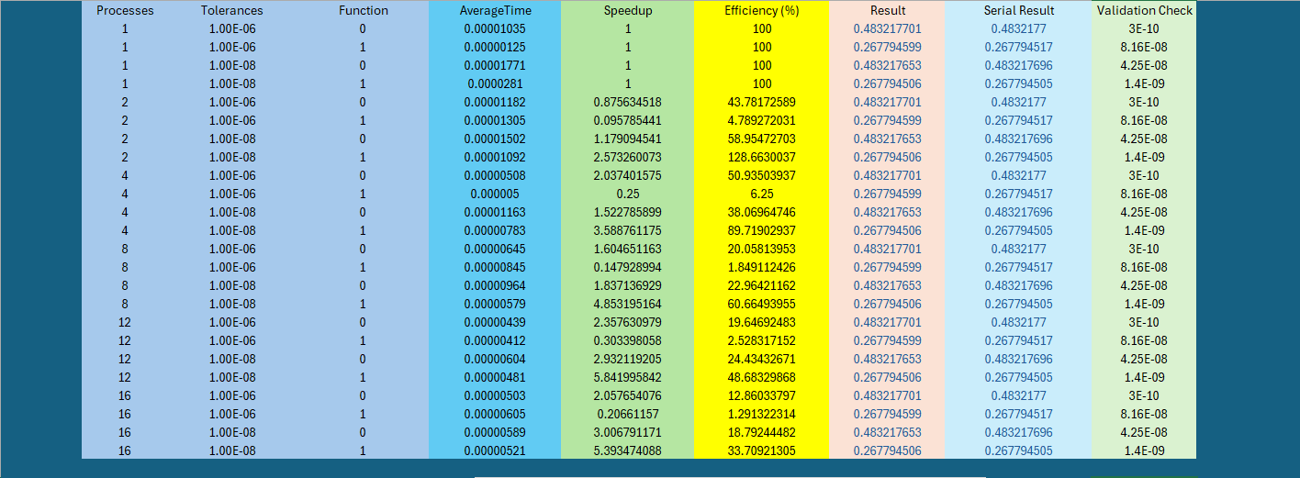
Mode 2:
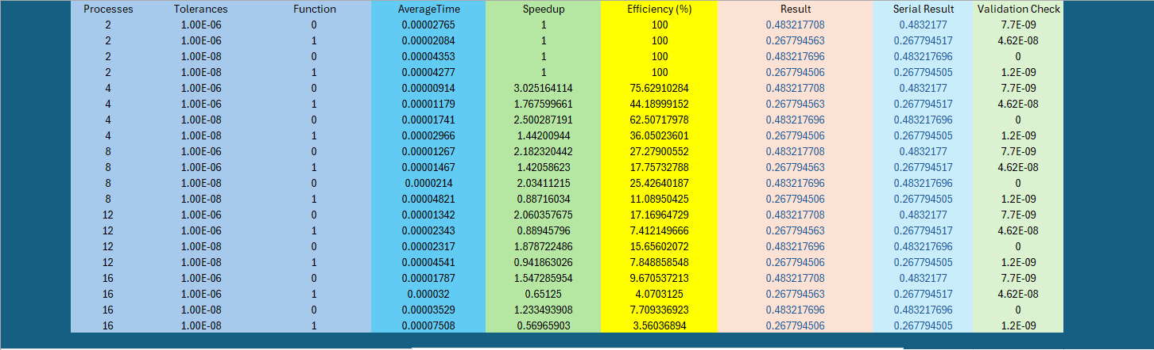
Part C) Plots:
Mode 1 Graphs:

Mode 2 Graphs:

Part D) Discussion:

- Why does static decomposition perform poorly for adaptive workloads?
Answer:
Static decomposition struggles because it assumes all parts of the problem take roughly the same amount of work, which is not true for this assignment’s problem set. With adaptive integration, some intervals get split a lot more than others, so some processes end up doing more work while others finish early and just sit there. This means that even though everything is evenly divided at the start, the actual workload would end up uneven after distribution.
- How does dynamic task creation improve load balance?
Answer:
Dynamic scheduling improves load balance by not committing to a fixed workload upfront. Instead, workers keep asking for more work as they finish, and new tasks get created as intervals are split. If one process finishes early, it just grabs more work from the master instead of staying idle. It ends up spreading the heavy parts of the problem across processes much better and increases efficiency.
- What is the cost of dynamic scheduling in MPI?
Answer:
The downside is that there is more communication, and thus more communication time involved. Workers are sending more tasks, getting/loading tasks, and sending results back, which adds to the overhead of the process. There is also some coordination cost since the master has to manage all of this, depending on the architecture. For smaller problems, this overhead can outweigh the benefits and make it slower than static or even serial.
- Which function benefited most from dynamic scheduling, and why?
Answer:
Function 0 benefited the most, specifically with a tolerance of 1e-5. Even though the function is relatively smooth, there are still small variations in how much work different intervals require. With static scheduling, those differences are not handled well, so some processes finish earlier than others. Dynamic scheduling helps by redistributing that leftover work, which leads to better overall utilization. Since the workload is super uneven, the improvement is not massive, but it is still noticeable compared to static scheduling.
Experimentation Environment:
